## horizontal line

**HISTOGRAM**

# **Problem Statements :**

Find the largest rectangular area possible in a given histogram where the largest rectangle can be made of a number of contiguous bars.

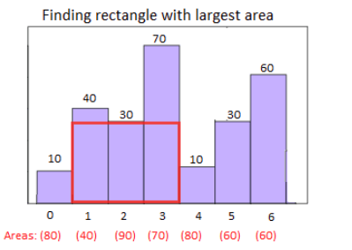

# **Input Format :**

First line contains a single integer N, denoting the number of bars in th histogram. Next line contains N integers, of which, denotes the height of bar in the histogram.

# **Constraints :**

1<=N<=10^6  
Height of each bar in histogram <= 10^9

# **Output Format :**

Output a single integer denoting the area of the required rectangle.

# **Sample Input :**

5  
1 2 3 4 5

**Sample Output :**

9

**Explanation :**

None

**Time Limit :**

**none**